Scheduling Appointments
Advisors are displayed under your Success Team on the right side of your OneDePaul portal.

Navigation
- Log in to OneDePaul
- On the OneDePaul homepage, click Make an Appointment
- Click Schedule an Appointment
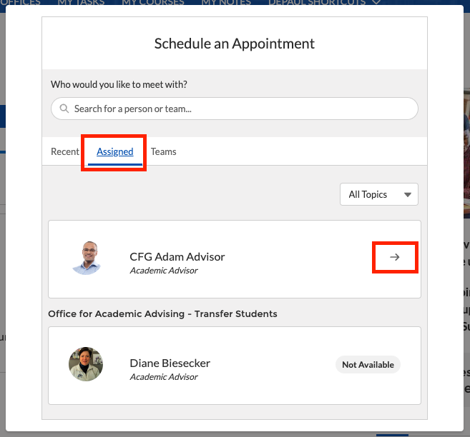
- Click the Assigned tab, then click on the arrow in the box of the advisor you wish to meet with.
- Choose the appropriate topic and sub-topic you wish to discuss.
- Choose the time that best fits your schedule.
  - Note: You can also click on the date that is displayed and choose a specific date.
- Next you can enter in a comment of specifics you would like to discuss with your advisor and finally confirm the appointment by selecting the location.
