Getting Started with OneDePaul
OneDePaul provides you with one central location to find the people on campus who can help you succeed. It gives you an easy way to connect with your advisors, instructors, and other resources at DePaul. You might also see notices about your academic performance and possible next steps sent to you by email.

Accessing BlueStar Through Campus Connect
- Go to Student Homepage > Advising, Progress, & Graduation > OneDePaul

OneDePaul’s Resources
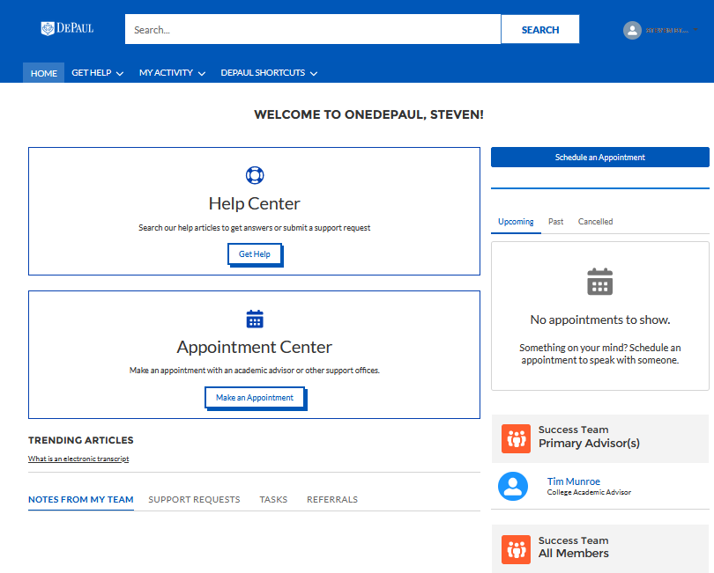
- Help Center: Where you can review knowledge articles and submit requests for assistance.
- Appointment Center: Where you can schedule an appointment with your advisor or other support areas.
- My Activity: Where you can review notes, comments, referrals, and tasks that have been shared with you. You may also view your instructors, check the status on your support requests, and view important announcements here.
- DePaul Shortcuts: Where you can find links to helpful resources and offices around the University.

